ish¿u ysñlï weúßKs $ All Rights Reserved

St. Peter's College

St. Peter's College

St. Peter's College

புனித பேதுரு கல்லூரி

புனித பேதுரு கல்லூரி

புனித பேதுரு கல்லூரி

புனித பேதுரு கல்லூரி

புனித பேதுரு கல்லூரி

புனித பேதுரு கல்லூரி

புனித பேதுரு கல்லூரி

புனித பேதுரு கல்லூரி

Ydka; mS;r úÿy,

Ydka; mS;r úÿy,

Ydka; mS;r úÿy,

Ydka; mS;r úÿy,

Ydka; mS;r úÿy,

Ydka; mS;r úÿy,

Ydka; mS;r úÿy,

Ydka; mS;r úÿy,

Ydka; mS;r úÿy,

Ydka; mS;r úÿy,

St. Peter's College

St. Peter's College

St. Peter's College

St. Peter's College

St. Peter's College

St. Peter's College

St. Peter's College

St. Peter's College

St. Peter's College

St. Peter's College

புனித பேதுரு கல்லூரி

புனித பேதுரு கல்லூரி

புனித பேதுரு கல்லூரி

புனித பேதுரு கல்லூரி

புனித பேதுரு கல்லூரி

புனித பேதுரு கல்லூரி

புனித பேதுரு கல்லூரி

புனித பேதுரு கல்லூரி

Ydka; mS;r úÿy,

Ydka; mS;r úÿy,

Ydka; mS;r úÿy,

Ydka; mS;r úÿy,

Ydka; mS;r úÿy,

Ydka; mS;r úÿy,

Ydka; mS;r úÿy,

Ydka; mS;r úÿy,

Ydka; mS;r úÿy,

Ydka; mS;r úÿy,

St. Peter's College

St. Peter's College

St. Peter's College

St. Peter's College

St. Peter's College

St. Peter's College

St. Peter's College

E

I, II

**wmrÈ. ix.S;h**

**Western Music**

**meh 02**

**Two Hours**

**08 fY%aKsh – f;jk jdr we.hsu - 2022**

**தரம் 08 - ஆண்டிறுதி மதிப்பீடு - 2022**

***Grade 08 – Third Term Examination - 2022***

Ydka; mS;r úÿy, - fld<U 04

புனித பேதுரு கல்லூரி, கொழும்பு 4

***St. Peter's College - Colombo 04***



Name: …………………………………………..…..…… Class: …….……… No: ……………

**Part - I**

* **Underline the most suitable answer.**

01. A music which is not based on sounds from nature,

i. Cuckoo waltz ii. Rain drop prelude

iii. Rustle of spring iv. Fuer Elise

02. Who is the best bird to imitate human speech?

i. Barbet ii. Grackle iii. Tailor bird iv. Sunbird

03. A drum which can be classified under “Vithathatha”

i. Davula ii. Geta beraya iii. Yak beraya iv. Thammattama

04. A composer of the Baroque period,

i. Haydn ii. Bach iii. Mozart iv. Beethoven

05. The drum which is used to accompany harvesting songs and folk dances,

i. Bummadiya ii. Davula iii. Udekkiya iv. Rabana

06. The composer of the opera “Marriage of Figaro”

i. Beethoven ii. Haydn iii. Handel iv. Mozart

07. The accompanying style “Alberti Bass” is found in,

i. Baroque ii. Classical iii. Romantic iv. Modern

08. A composition for a single player,

i. Quartet ii. Trio iii. Duet iv. Solo

09. Number of strings in a guitar,

i. 4 ii. 6 iii. 8 iv. 2

10. Enharmonic equivalent of B,

i. A double flat ii. A flat

iii. A sharp iv. A double sharp

11. A chromatic semitone above G,

i. G sharp ii. G double sharp

iii. G Natural iv. A flat

12. A diatonic semitone below F,

i. E ii. E sharp iii. F flat iv. F sharp

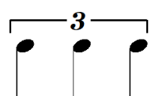

13. equals to a,

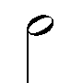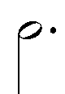

 i. ii. iii. iv.

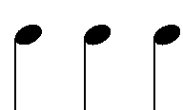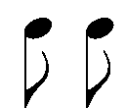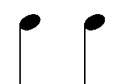14. is,

i. ii. iii. iv.

15. The key having 5 sharps,

i. E major ii. B major iii. D major iv. A major

16. The interval having 4 semitones and 3 alphabetical letters is a,

i. Minor 3rd ii. Perfect 4th iii. Major 3rd iv. Perfect 5th

17. Which of the following is not in ternary form?

i. London bridge ii. Three blind mice

iii. Ash grove iv. Drink to me only

18. The opposite of the term Decrescendo,

i. Diminuendo ii. Crescendo iii. Allegro iv. Adagio

19. Number of lines in the great staff,

i. 11 ii. 10 iii. 8 iv. 12

20. The highest pitched orchestral string instrument,

i. Violin ii. Viola iii. Cello iv. Double bass

***(1 $×$ 20=20)***

**Part - II**

* **Answer question no 01 which is compulsory and two others.**

1. The following questions are based on the given music.

**Round The Clock**

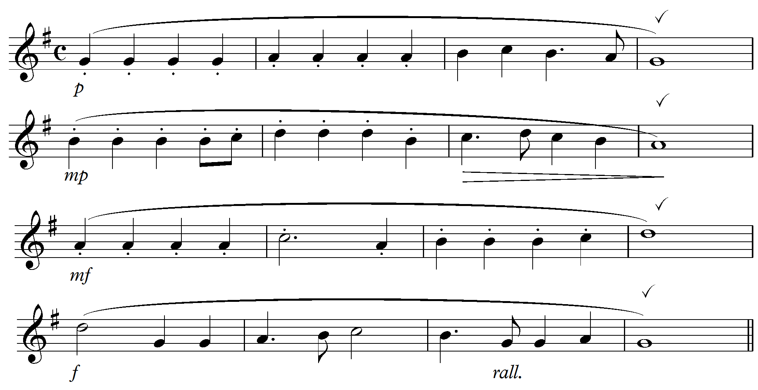

i. In which key is this written? ………………………….……………………

ii. What is the time signature? ………………………………………………...

Explain ………………..……………………………………………………

iii. How would you play the first 4 notes of the melody?

………………………………………………………………………………

iv. What is the frequency of the first crochet of bar 2

………………………………………………………………………………

v. How many phrases are there in the melody?

………………………………………………………………………………

vi. Give the English meaning of the following.

P - ……………………………… mp - ………………………………

f - ……………………………… mf - ………………………………

***(10 Marks)***

02. (a). Write these notes as crotchets. ***(04 Marks)***

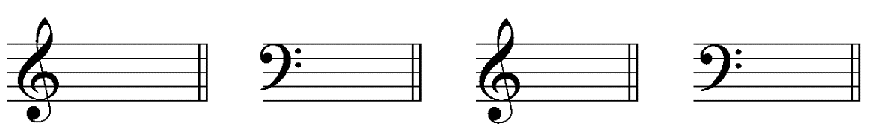

G sharp

On a line

Middle C

flat

G above

The stave

F below

The stave

(b). Write the enharmonic equivalent of the following. ***(04 Marks)***

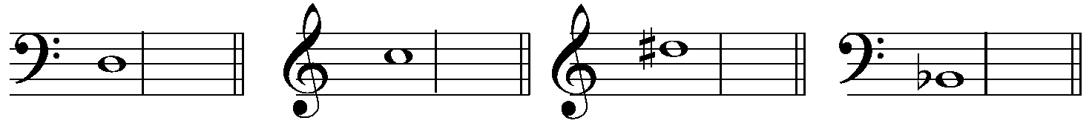

(c). Give the English meaning of the following terms. ***(02 Marks)***

Allegro - ___.................................._____Adagio - ………………………………

03. Write the following scales as required.

(a). E major scale ascending in treble clef with key signature as minims. ***(03 Marks)***

|  |
| --- |
|  |
|  |
|  |
|  |

(b). Ab major scale descending in bass clef as crotchets with accidentals. ***(03 Marks)***

|  |
| --- |
|  |
|  |
|  |
|  |

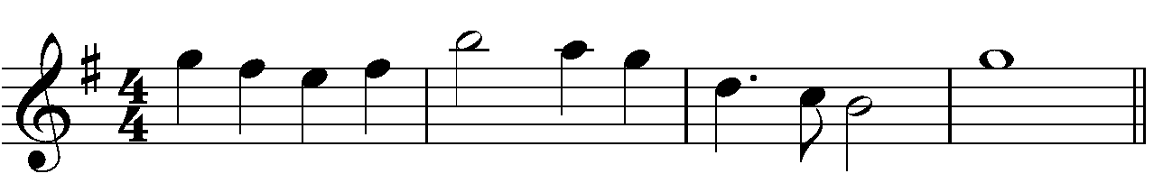 (c). Transpose this melody one octave lower. ***(04 Marks)***

|  |
| --- |
|  |
|  |
|  |
|  |

04. (a). Write the following intervals. ***(04 Marks)***

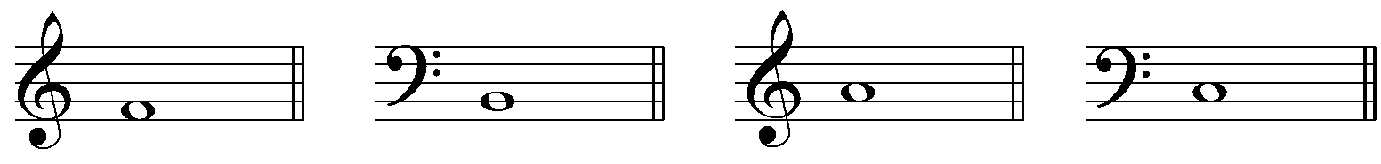

Perfect 4th

Perfect 5th

Major 2nd

Minor 3rd

(b). Name these notes. ***(04 Marks)***

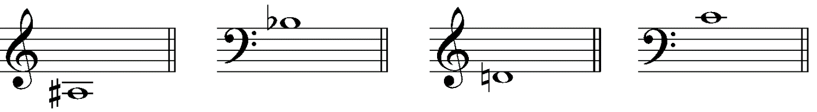

________________________________________________________________________

(c). Write these triads with key signatures.  ***(02 Marks)***

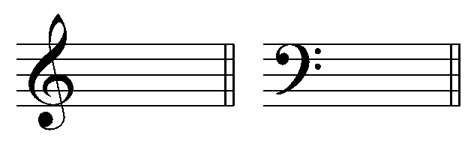

Tonic triad of

F major

Tonic triad of

G major